Yonia’s Personal Project

**Nab Home Loan Calculators**

<https://www.nab.com.au/personal/home-loans/calculators/loan-repayments-calculator>

**Test cases：**

Base Test:

1. Check if the page load time is within the acceptable time. (With an automation solution)

Home Page:

1. Check result of clicking Login button. (With an automation solution)
2. Check result of clicking Calculate borrowing power button. (With an automation solution)

Login Page:

4. Validate invalid UserID. (With an automation solution)

5. Check results on missing Username and Password. (With an automation solution)

Calculator Page:

6.Check result of clicking Next button with missing field

P Question:

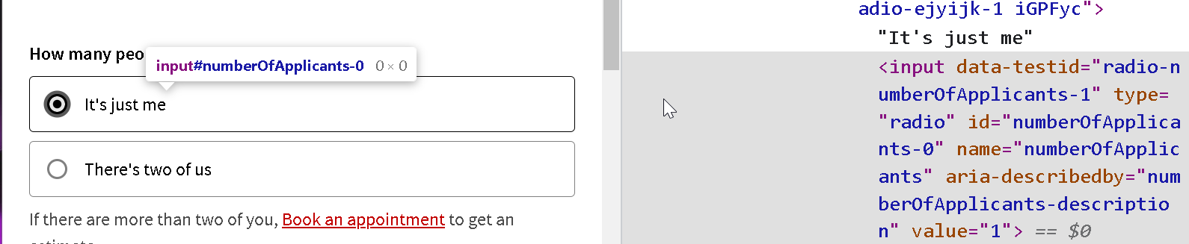

CalculatorPage

Why not using id